eQuip message
2-6 January 2023 eQuip
Hermannsburg
Theme: Sawubona; You are a God who sees me!

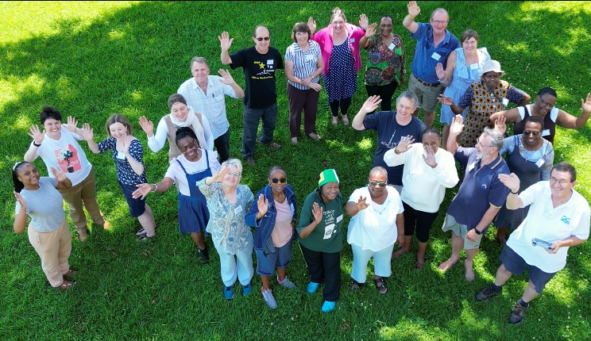
The year 2023 started with a bang, with all the roads leading to Hermannsburg. The watchword for the year which was also the theme of the eQuip, Genesis 16:13 ushered us into the New Year. It was again a jam-packed programme of fellowship, fun but educative games and a wealth of knowledge sharing by our ever-selfless presenters: the outgoing bishop Horst Müller, Rev Dr’s Detlev and Gertrud Tönsing. For the first time in the history of eQuip Rev Dr Gertrud Tönsing composed the eQuip song.
23 participants were in attendance and it was a joy to be able to come together again face to face, and touch and hug each other again. It was a journey of 10 years during which we experienced pain, sorrow, anxiety, hopelessness but also touched by God’s love and reminded that God sees us.
The eQuip camp was started in 2013. We remembered with sadness and gratefulness those who passed on and those who started the journey in 2013 and never missed a single attendance, like Joyce Dipale and others.
“Sawubona”: Where was God in the storms and the devastation of COVID-19, the floods that left many dead and homeless, the horrible roads accidents and political uncertainty? We felt alone and helpless. Confirmation and comfort were unpacked in Genesis 16: 13; the Theme of the eQuip 2023: “Sawubona - You are a God who sees me. God our compass and GPS has ushered us into the year 2023 and will plan for us going forward. God will navigate through our storms.
The story of Hagar affirms that God sees what we as human beings do not see. When Hagar was in the desert, God saw her. God sent her back to the challenges she faced. So, this does not in any way mean that if God sees you, your troubles will go away. God will help you cope.
What we learnt from the story of Hagar is that even when we feel like we are alone and no one else sees what is going on in our lives, God does. He sees every hurt, every tear, every joy and every victory. No matter what we are going through in our lives we must know that God sees us and knows our hearts. He loves us more than we can ever imagine, and whatever comes our way God is always there to help us through. Through eQuip we were able to see a God who loves us and not a God who inflicts pain on us.
We encourage you all to join the camp next year. Young and not so young are welcome! Bring the kids along! Grandpa and Grandma can also come along.
On your marks! Get set! Go! The next eQuip 2024 will be held on 2-7 January 2024. You don’t want to miss this. “U zo qwala!”
For further information on the eQuip please visit the NELCSA webpage: www.nelcsa.net.
Message compiled by Ann Mokhine and Elsabe Duvenhage.

