Mission and Diaconical Projects in Augsburg Congregation
Since the year 2000 a number of different mission and diaconical projects have evolved within the work done by the Augsburg Mission Committee. As a voluntary group we first of all want to thank our Lord for the opportunities He has given us to build His Kingdom and for leading us by His Spirit! We have experienced how God answers prayers and opens doors where we ask for it! Furthermore we as a committee have been equipped and strengthened in our work through the involvement of the Kingfisher Mobilizing Program, which has been adopted and implemented in our congregation since 2008.
1. The Appointment of two Evangelists
In 2005 a number of Tent Crusades took place, in close cooperation with the MET Team of Pastor Dick. As is so often the case, with such evangelistic events, we soon realized that we needed “shepherds” to do the vital follow-up work. In 2006 we were able to offer to members of the MET Team full-time employment as preachers and evangelists in the Commondale (Augsburg) area. It is their task to visit farms, doing morning devotions at the workplace, visiting sick people, participate at funerals if needed, visit schools and Crèches and to hold Sunday services. The stipends paid to the Evangelists are made possible through the congregational offerings made specifically for local mission work, as well as donations made by individual members.
2. Crèche’s and Orphan Support
In the 1990’s a number of Farm Crèches were started as part of the Rural Foundation Program, while teachers were trained to prepare the farm kids for school entry. Today many of these teachers are now being paid by the Education Department. In this way quite a number of women have been empowered and are offering a valuable service to their communities. Due to the very high HIV/ AIDS infection rate in our area, many of the children are orphans and these are supported by handing out clothing and basic foods especially for the school holidays when they do not have access to the school feeding programs.
3. Peer Educator Project
Since 2005 the high incidence of HIV related diseases and absenteeism, as well as more deaths resulting from AIDS prompted us to do something about the growing pandemic. It led to the decision taken by a combined meeting with the Braunschweig Mission Committee together with Pastor Markus Kallembach, the then Dean of the Igwa Circuit ( ELCSA) to practically do something about the situation. After some serious discussions and planning it was decided that only through proper education and direct involvement of affected communities a sustainable long term solution could be obtained. In 2007 a training program of Peer Educators (PE’s) was initiated, with the aim of training suitable candidates on each farm of the area, so that they in turn would be able to pass on this knowledge to their peers in the villages and at the work place. In this way the Thol’ulwazi Thol’impilo Project (To gain knowledge is to gain life) was born. Since then more than 120 Peer Educators have been trained and about 80 farms benefit from this service. We have seen how the stigma against HIV|AIDS has been broken down and
2.
how these PE’s have been empowered and also benefited financially through stipends paid by the Department of Health.

4. ONE-STOP Mobile Clinics
We soon realized that in order for the gained knowledge to be effective and resulting in farm dwellers having themselves tested (VCT), the existing social and health services were far from effective and conducive for this to happen. This led to the decision to fund raise and plan towards implementing the services of privately administered mobile clinics. Through the generous support of the CHABAHIVA Trust (Churches and Business against HIV\AIDS) and NRW (North Rhine Westphalia) Partnership with the Mpumalanga Province we were able to purchase and equip our first Mobile Clinic by August 2009. The official launch however only took place in February 2010, when the MOA with the Dept. of Health Mpumalanga was finalized. This agreement ensured the appointment of staff and the necessary medical supplies for a fully functioning primary health care clinic, visiting about 40 farms in monthly intervals.
Since there are many MONDI Farms in our area, the company donated funds towards the acquisition of a second Mobile Unit to service their farms under similar conditions. The second unit started to operate in January 2011, while more Peer Educators were trained for those farms.
Our NGO is further responsible for the appointment of a lay councilor to assist with the VCT on each of the Mobile Units. We also carry the running and maintenance costs of the vehicle. The initiative was registered as a PBO (Public Benefit Organization) and serves as a pilot project and example of how individuals, businesses and government can take hands for a common cause. At this stage the life-saving ARV’s are not yet available through the Mobile Clinic Service, but we have been given the assurance that our Mobile Units will be the first to hand out ARV’s on a trial basis.
Our next aim is to establish a satellite clinic at Commondale, where other social services, orphan care and pre-school education could be further projects to be developed.
5. Borussia Commondale
Through the NRW\ Mpumalanga partnership a further initiative developed during the preparations of the 2010 World Cup, namely a soccer club Borussia Commondale. This was the brainchild of a social worker from Dortmund who intends to reach the youth through soccer, thereby opening new perspectives and hope for the many unemployed and destitute youngsters in our area. This initiative will be working closely together with the Peer Educator Project to also reach the most vulnerable on issues regarding HIV and AIDS. A long term goal is to also build a soccer ground at Commondale near the envisaged Commondale Community Centre.

3.
6. Lay Preacher Training
A further project in the field of lay preacher (discipleship) training was started in 2009 in conjunction with Genesis Ministries and Welcome Ngwenya, one of our Evangelists. With this endeavor we hope to train as many disciples as possible on the various farms (similar to the Peer Educators). We hope that little cell groups or home groups will develop, each led by one or two of the trained lay preachers. These groups will then eventually form a congregation or church (Commondale Christian Fellowship) which will then come together once or twice in a month for communion or baptisms at the Tent Church at the Commondale Community Centre. This whole project stands under the leadership of Pastor Tom McSevenney from Genesis Ministries. Further training of the lay preachers will be done by Peter Stockhölm of the All Africa Bible Institute Hillcrest. This is a very exciting project and is indeed a form of church planting in a way we had never planned before. We need a lot of wisdom in the planning phases in order to develop a sustainable ministry that is not only linked and dependent on a few individuals. It is also not our intention to be linked or dependent to any of the existing denominations or main line churches, in order to be inviting and open for all Christians who want to commit themselves to this Fellowship.
7. The Way Forward?
Out of the multitude of the different projects running concurrently in the Augsburg Congregation, the idea of a Commondale Community Centre was borne. Since Commondale is centrally situated for the whole community and due to certain structures already available at Commondale, we as Mission Committee presently are involved in the planning and the founding of such a centre. This can be represented diagrammatically as follows: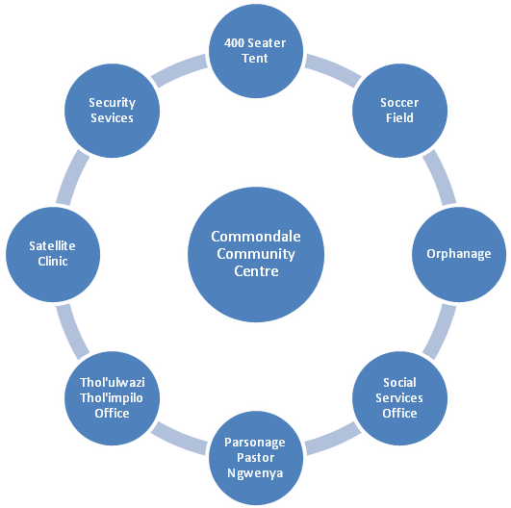
4.
Structures already available are an old Railway House, Wooden Structures (Wendy House) and sufficient space for further Developments. The first phase would be to renovate the old Railway House (i.e. painting, fixing roof, windows and doors, installation of electricity and fixing plumbing, erection of security fence). This house will serve as parsonage of Pastor Welcome Ngwenya and he will then also be responsible for the overseeing of the Centre.
The Wendy Houses were put up by the Dept. of Social Services some years back. They have never been used due to the fact that no electricity was available. With this new initiative, it is hoped that Social Services will be coming on board, once electricity is available on site.
Another goal is to erect a 400 seated tent next to the parsonage to serve as church and community hall for any community functions.
As Mission Committee we constantly endeavor to further support within the congregation for these projects and hope to encourage individual members to realize their God- given gifts and opportunities to get involved in Kingdom building opportunities. We all should be light of the world and the salt of the earth to help build God’s Kingdom here on earth!
We as committee pray for the guidance, wisdom and leadership of the Holy Spirit and the love of our Lord and savior Jesus Christ, who has given us the command of neighborly love and the great commission to be Kingdom Builders!

