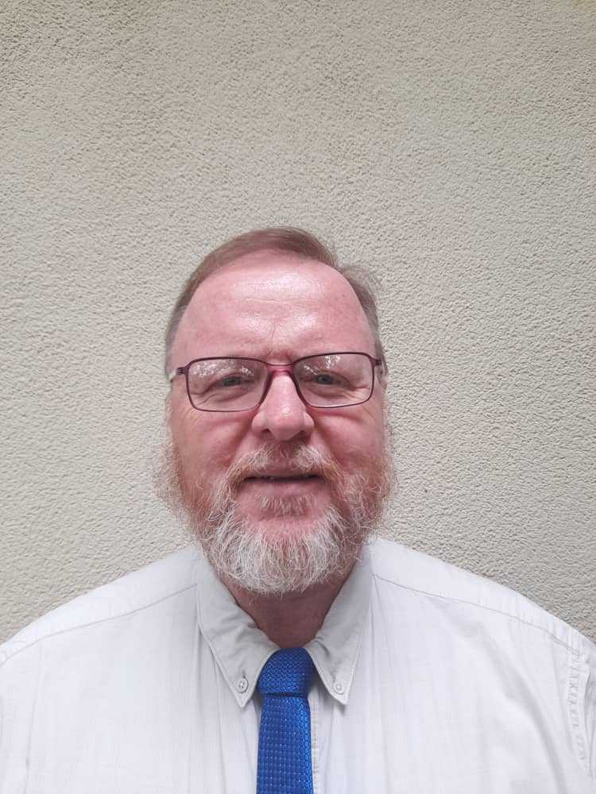
Profile of Pastor

1. Name Reinhold Bernhard Schiele
Contact email reinhold.schiele@gmail.com

2. Personal history:
Date of birth 30.10.1964
Where I grew up: South Africa: Limpopo Province
Where I went to school: Phalaborwa Primary School; Deutsche Schule Hermannsburg

- Marital status: Married
Name of spouse: Ilse Schiele
Name/s of child/ren: Bernhard and Dana

4. Studies:
Where and when I studied theology?: University of Natal: 1983-1987
Any subsequent/other studies or previous occupations: No previous occupations.
I have done various courses of in-service training:
Multiplicator Seminar: Auszug aus dem Schneckenhaus ca. 1994
Introduction to Sipedi - 1996
Ehe im Pfarrhaus - Seelsorge 1999 (Marriage in the manse)
Zeitplanung (Tempus) 1999 (Time planning)
Arbeitstechniken (Tempus) 1999 (Work techniques)
Einführung in Bibliodrama 1999 (Introduction to Bibliodrama)
Informationstreffen mit der Redakteurin des Niederländischen Ökumenischen Gesangbuchs 1999 (Information meeting on the Ecumenical Hymn book Netherlands)
Taylor-Johnson Temperament Analysis (2006)
Seminar for Brassbands and Conductors with Joachim Tobschall (March 2009 and 2010)
Workshops for Popular Music in Görlitz: November 2010 with Steffen Peschel - Modern Rhythems; November 2011 with Michael Schütz - popular Rythmen; November 2012 - with Richard Roblee - Basics of Swing Music.
First Aid Course (May 2013)
Brass Band Leader Training (2010-2013),
LWF Seminar on “Peace and Reconciliation” in the Writings of Martin Luther in Lutherstadt Wittenberg (March 2017)

5. Congregations and positions in which I served:
5.1 NELCSA:
Northern Transvaal Parish, Limpopo Province, South Africa (1993 – 2000) – Pastor
Markus Congregation - Piet Retief und Pfingstgemeinde - Ermelo, Mpumalanga Provinz, South Africa (2001-2004) – Pastor
Member of Northern Natal Circuit Council (2003) – Deputy Dean
Wartburg Congregation, KwaZulu-Natal Province, South Africa (2005 - 2008 ) -- Pastor
Lay-preacher Training (2004 – 2008) - Coordinator
Senior Citizen´s Camp (2005 – 2008)

5.2 Exchange Pastor in the Evangelische Kirche Berlin Oberschlesische Lausitz (EKBO):
Ruhland Congregation Pastor in 50% position; Circuit Pastor in 50% position, responsible to oversee vacancies in various neighbouring congregations: Ortrand/Großkmehlen, Kroppen and Lindenau/Schraden (2008-2014) – This included a Preschool, Church Cemeteries and Renovation and Building Projects concerning Historical Buildings
Berlin Mission, Advisory Board Southern Africa as Resource person (2008 - 2014)
Pastor´s Convention Council Circuit Hoyerswerda (2012-2013)
Visitator in the Circuit (2011 and 2013)
Circuit Council as Deputy Dean (2013)
5.3 ELKIN(DELK):
German Evangelical Lutheran Congregations of Grootfontein, Otavi and Tsumeb, Namibia (2015 – present) – Pastor

6. Personal strengths and interests:
The ability to encourage people to be happy; loyalty; experience with multi-Congregational situations; I am very much interested in Brass Band work as an integral part of a congregation: Fellowship in music.

7. Hobbies:
Reading, Films, Music, Nature - Bird watching; Cycling, Hiking, Pottery, Painting

8. What do you think, makes church relevant to people and society today?
Church is the institution in this world that proclaims the good news of Jesus Christ to all people. Its proclamation seeks to be relevant to the daily experiences of the people. It is relevant when it reflects on the experiences of people living in our society: The rich, the poor, the healthy and the ill, the living and the dying, the old and the young, the faithful and the unfaithful, people at the core as well as people at the fringe of our congregations. Church becomes relevant, when it addresses the needs of its members and encourages them to overcome their fears and doubts. My guiding biblical principles are expressed by two sections: (1.) Psalm 100 which calls the faithful to rejoice in God, joyfully serving Him. (2.) John 13:34+35 which reminds us that being a Christian is expressed by the love we show towards one another.

